FY2026 Events Calendar – Office of Small Business Programs, Fort Worth District

Date | Event | *IP / V | Location | Link / Email
Oct 1, 2025 | SAME Fort Worth Post Luncheon (Networking Opportunity) | IP | FW | https://samefortworth.org
Oct 8, 2025 | Business Beyond the Battlefield Conference (BBBC)  at National Medal of Honor Museum, Arlington, Texas | IP | Arlington, TX | https://bbbc.uta.edu
Oct 9, 2025 | Capability Briefing Day (9AM-4PM) | V | Teams | www.swf.usace.mil/OSBP
Oct 16, 2025 | City of Fort Worth Public Involvement–Open House (Central City) | IP | Evening | https://www.trwd.com/centralcity/
Oct 22, 2025 | El Paso APEX Accelerator (SBA) Veterans Business Conference | NA | El Paso | https://www.elpasococ-events.org/vbc
Oct 23, 2025 | Capability Briefing Day (9AM-4PM) | V | Teams
Oct 23, 2025 | Virtual Matchmaking 360 – National HUBZone Council  (Construction / Engineering: 1:00PM – 4:00PM CDT) | V | Teams | https://hubzoneconference.my.canva.site/#matchmaking-360
Nov 4, 2025 | Capability Briefing Day (9AM-4PM) | V | Teams
Nov 5, 2025 | SAME Fort Worth Post Luncheon (Networking Opportunity) | IP | FW | https://samefortworth.org
Nov 13, 2025 | NW Louisiana APEX Accelerator (SBA) Industry Day | NA | Shreveport | https://www.nwla-apex.org/events
Nov 18, 2025 | Capability Briefing Day (9AM-4PM) | V | Fort Worth
Nov 19-21, 2025 | SAME National Federal Small Business Conference | NA | Phoenix, AZ | Federal Small Business Conference for the A/E/C Industry 2025 - SAME
Nov 20, 2025 | Corpus Christi - GovConnect 2025: Govt & Business Summit | NA | Corpus Christi | https://www.delmar.edu/apexaccelerator/
Dec 3, 2025 | SAME Fort Worth Post Luncheon (Networking Opportunity) | IP | FW | https://samefortworth.org
Dec 4, 2025 | Capability Briefing Day (9AM-4PM) | V | Teams
Dec 12, 2025 | Dyess Air Force Base Industry Day (B-21 Program) | IP | Abilene | https://www.nwtapex.org/
Dec 18, 2025 | Capability Briefing Day (9AM-4PM) | V | Teams
Jan 7, 2026 | SAME Fort Worth Post Luncheon (Speaker SWF Commander) | IP | FW | https://samefortworth.org
Jan 15, 2026 | Capability Briefing Day (9AM-4PM) | V | Teams
Jan 22, 2026 | Capability Briefing Day (9AM-4PM) | V | Teams
Feb 4, 2026 | SAME Fort Worth Post Luncheon (Networking Opportunity) | IP | FW | https://samefortworth.org
Feb 5, 2026 | Capability Briefing Day (9AM-4PM) | V | Teams
Feb 19, 2026 | Capability Briefing Day (9AM-4PM) | V | Teams
Mar 4, 2026 | SAME Fort Worth Post Luncheon (Networking Opportunity) | IP | FW | https://samefortworth.org
Mar 5, 2026 | Capability Briefing Day (9AM-4PM) | V | Teams
Mar 19, 2026 | Capability Briefing Day (9AM-4PM) | V | Teams
Apr 2, 2026 | Capability Briefing Day (9AM-4PM) | V | Teams
Apr 14, 2026 | Fort Worth District SB Industry Day (Presentations Day) | IP | Fort Worth | https://samefwindustryday.com/
Apr 15, 2026 | Fort Worth District SB Industry Day (1-on-1 Mtgs Day) | IP | Fort Worth | https://samefwindustryday.com/
Apr 16, 2026 | Capability Briefing Day (9AM-4PM) | V | Teams
May 5-7, 2026 | SAME San Antonio Post Small Business Market Research Fair | IP | San Antonio | https://www.same.org/san-antonio/events/
May 19, 2026 | SAME Joint Engineer Training Conference (JETC) | NA | Portland, OR | https://www.samejetc.org/
May 21, 2026 | Capability Briefing Day (9AM-4PM) | V | Teams
Jun 3, 2026 | SAME Fort Worth Post Luncheon (Networking Opportunity) | IP | FW | https://samefortworth.org
Jun 4, 2026 | Capability Briefing Day (9AM-4PM) | V | Teams
Jun 10-11, 2026 | Louisiana APEX Accelerator & National Center American Indian | NA | Marksville, LA | https://www.nwla-apex.org/events/
Jun 18, 2026 | Capability Briefing Day (9AM-4PM) | V | Teams
June 23, 2026 | Dyess Air Force Base Industry Day (B-21 Program) | IP | Abilene | https://www.nwtapex.org/
July 8, 2026 | SAME Fort Worth Post Luncheon (Networking Opportunity) | IP | FW | https://samefortworth.org
July 8, 2026 | Informal Reverse Industry Day-Host Small Business Office SWF | IP | Fort Worth | Christina.J.Frey@usace.army.mil
July 20, 2026 | SAME Dallas Post Luncheon (Event Speaker) | IP | Dallas | https://www.same.org/dallas/
July 21, 2026 | Project Industry Day: MDCIOC, Lackland AFB (PDB + OTA) | IP | San Antonio | Christina.J.Frey@usace.army.mil
Aug 5, 2026 | SAME Fort Worth Post Luncheon (Networking Opportunity) | IP | FW | https://samefortworth.org
Aug 2026 | Build Fort Worth 2026 Construction Expo (FWHCoC) | IP | Fort Worth | https://buildfw.org/ (Specific Date TBD)
Aug 12, 2026 | El Paso APEX Accelerators Procurement Conference (Fort Bliss) | IP | El Paso | https://www.elpasococ-events.org/procuremenent-conference
Sep 2, 2026 | SAME Fort Worth Post Luncheon (Networking Opportunity) | NA | FW | https://samefortworth.org
Oct 27, 2026 | Cross Timbers APEX Govt Procurement Conference (DFW Area) | IP | Hurst, TX | https://www.uta.edu/research/centers/cross-timbers
TBD | Red River Army Depot Industry Day (Specific Date TBD) | IP | Texarkana | https://www.uta.edu/research/centers/cross-timbers
TBD | Fort Polk Industry Day (Specific Date TBD) | IP | Leesville, LA | https://www.nwla-apex.org/events/
TBD | Fort Hood Industry Day | IP | Killeen | https://apexaccelerator.iedtexas.org/
TBD | Central City (Fort Worth) & Dallas Floodway Industry Day | IP | Fort Worth | (Specific Date TBD)
TBD | Reverse Industry Day(s) – (Industry asks Govt Questions) | IP | FW Room | Offered Quarterly at Fort Worth District
* IP = In-Person / V = Virtual / NA = Not Attending

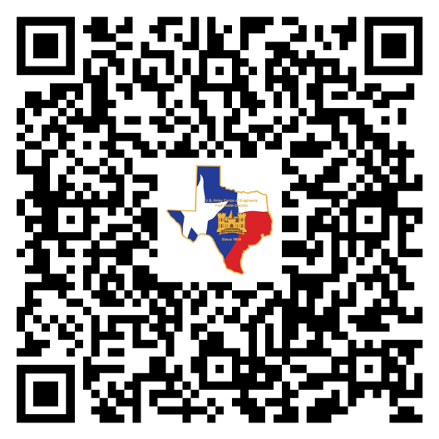
Distribution List Request
Want to be on our distribution list, Email Ms. Frey at Christina.J.Frey@usace.army.mil

Capability Briefing Days
Offered twice a month / 1st and 3rd Thursday(s) / October thru July
Capability Briefings NOT offered during 4th Quarter of Fiscal Year
See Events Calendar for dates / Virtual preferred / In person available

REQUEST Capability Briefing
Email Capability Statement to Ms. Frey at Christina.J.Frey@usace.army.mil
Include SAM.gov UEI Number & CAGE Code.

1st Priority to SB
Small Business (SB) have 1st priority over Large Business (LB).
LB MUST include a SB to present Capability Briefing. Opportunity Forecast
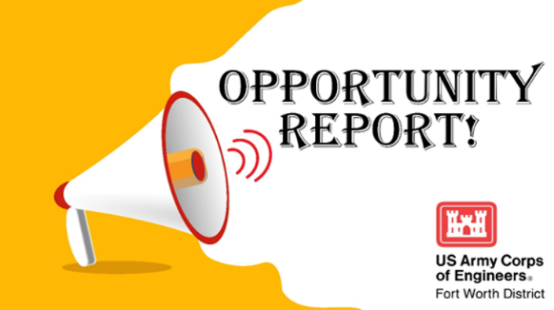
The SB may be Joint Venture, Mentor Protégé, Partnership, or Subcontractor.
Include SB’s SAM.gov UEI & CAGE Code with request.
LB: Be prepared to discuss SB Subcontracting opportunities.

Prime & Subcontractor Resources
View all the APEX Accelerator Links that support Fort Worth District AOR on website.
Veterans Business Outreach Center (VBOC) Link available on website.

NEW to Federal Contracting
Contact your local APEX Accelerator to LEARN how to do business with USACE.
https://www.apexaccelerators.us/#/service-area-locator

Download on Website

Office of Small Business Programs
Fort Worth District (SWF), U.S. Army Corps of Engineers (USACE)
View Opportunity Forecast (Updated Monthly), FAQs (Frequently Asked Questions), & Events at
https://www.swf.usace.army.mil/Business-With-Us/Office-of-Small-Business-Programs/

