MARINE FORCES RESERVE BAND
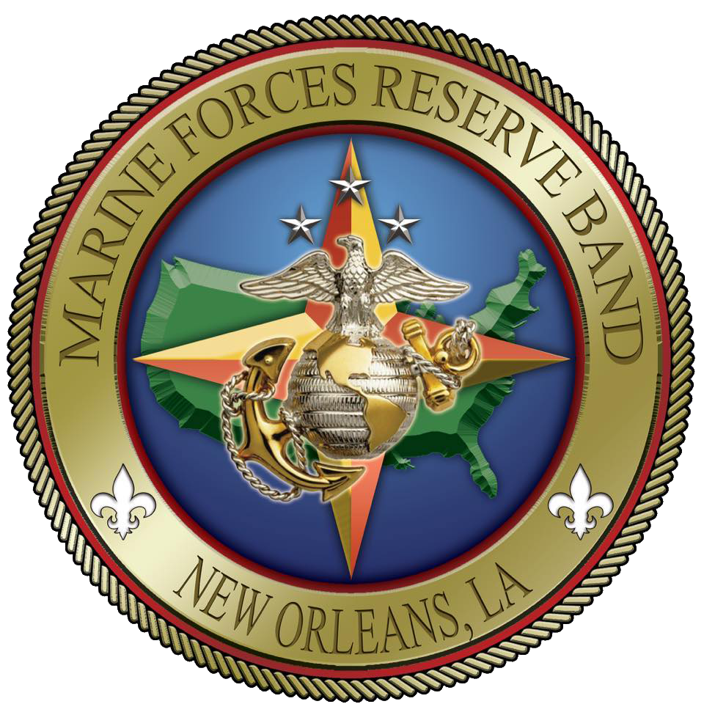
Press package

Under the Direction of

CHIEF WARRANT OFFICER 2 STEVE TALBOT

GENERAL INFORMATION
The Marine Forces Reserve Band was established October 1, 1978 and stands as one of ten Marine Corps field bands. The unit is comprised of active duty Marines stationed aboard the Marine Corps Support Facility in New Orleans, Louisiana. The band is attached to Marine Forces Reserve, traveling to numerous stateside locations to provide musical support for the Fourth Marine Logistics Group, Fourth Marine Aircraft Wing, Fourth Marine Division, and Force Headquarters Group.
Each member of the band is a graduate of Marine Corps Recruit Training and Marine Combat training, and they complete annual physical fitness and combat training requirements including weapons and swim qualifications. Several members have served as Marine Drill Instructors, Recruiters, Embassy Security Guards, or deployed in support of Operations Iraqi and Enduring Freedom.
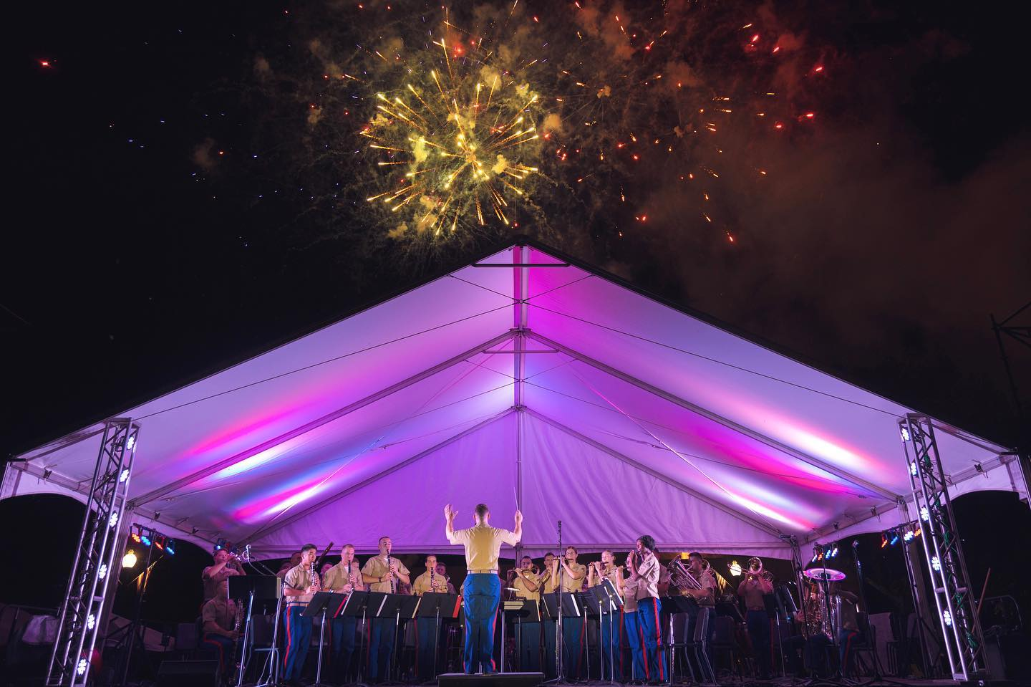

The Marine Forces Reserve Band performs over 350 concerts, parades, and ceremonies for more than 8 million people annually. The Band has performed in many recognized events which include:
Houston Livestock Show and Rodeo (Houston, TX)
Fiesta Days Celebration (San Antonio, TX)
Pro Football Hall of Fame Parade and Enshrinement Ceremony (Canton, OH)
Fleet Week New York (New York, NY)
Super Bowl XLVII (New Orleans, LA)
Country Music Awards Fest (Nashville, TN)
Mardi Gras Parades and Events (New Orleans area, LA)

STAFF
Band Officer, Principal Conductor, Officer in Charge

CHIEF WARRANT OFFICER 2 STEVE TALBOT

Bandmaster, Staff Non-Commissioned Officer in Charge
MASTER SERGEANT JUSTIN A. HAUSER

Enlisted Conductor

GUNNERY SERGEANT AMANDA KRANENDONK

Drum Major

STAFF SERGEANT JOSHUA T. WAGNER

Small Ensemble Leader

GUNNERY SERGEANT JUSTIN A. BILLINGSLEY

Instrument Repair Technician

GUNNERY SERGEANT MATTHEW L. KOSCHESKI

BAND OFFICER

CHIEF WARRANT OFFICER 2 STEVE TALBOT

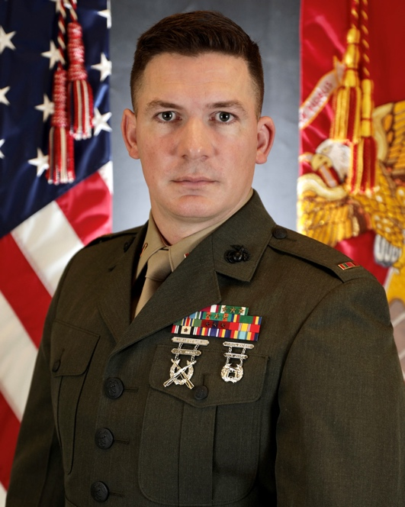
Chief Warrant Officer 2 Steve Talbot is a native of Yorkshire, England and graduated from Harborfields High School on Long Island, New York. He attended the State University of New York at Buffalo before enlisting in the Marine Corps in May of 2003.
Upon completion of recruit training at Parris Island, South Carolina, and Marine Combat Training at Camp Geiger, North Carolina, PFC Talbot checked aboard the Armed Forces School of Music in Virginia Beach, Virginia. In 2004, Lance Corporal Talbot graduated from the Basic Music Course and checked aboard the 2nd Marine Aircraft Wing Band in Cherry Point, North Carolina for duty as a trombone instrumentalist. During this tour he was promoted to corporal and sergeant, and he served as the acting Small Ensemble Leader.
In 2007, Sergeant Talbot deployed in support of Operation Iraqi Freedom, where he was attached to 2nd Low Altitude Air Defense (LAAD) Battalion for duty at the Tactical Air Command Center as the Military Police section's Sergeant of the Guard. In 2008, Sergeant Talbot transferred to the Quantico Marine Corps Band in Quantico, Virginia where he led the Brass Quintet and served as the Non-Commissioned Officer in Charge of the band’s training section. In 2009, he attended the Unit Leader Course at the Armed Forces School of Music and was promoted to staff sergeant. In 2010 he transferred to the Albany Marine Band in Albany, Georgia where he was selected for the band command element billet Small Ensemble Leader.
In 2012, Staff Sergeant Talbot transferred to the 2d Marine Division Band in Camp Lejeune, NC for service as Small Ensemble Leader. During this tour, he attended the Sound Reinforcement Course at the Naval School of Music and toured with the Marine Corps All-star Jazz Band. In 2014, Staff Sergeant Talbot checked aboard the Naval School of Music for service as an instructor, where he also served as the Head of Basic Academics. He was promoted to Gunnery Sergeant in 2016 and selected as the Fiscal Year 2016 Staff NCO Musician of the Year by HQMC while attending the Senior Musician Course.
In 2017, Gunnery Sergeant Talbot served as the Marine Detachment, Naval School of Music’s Detachment Gunnery Sergeant, completed the Audition Trainer Course, and was selected for the Warrant Officer program. He attended the Warrant Officer Basic Course at The Basic School in Quantico, Virginia in 2018. In 2018, Warrant Officer Talbot served as the Director and Officer in Charge of the U.S. Marine Corps Forces, Pacific Band in Kaneohe Bay, Hawaii. He was promoted to his current rank in August 2019.
In 2022, Chief Warrant Officer 2 Talbot assumed his current role as the Director and Officer in Charge of the Marine Forces Reserve Band in New Orleans, LA. A distinguished graduate of Expeditionary Warfare School, he is also the recipient of the Colonel George S. Howard Citation of Musical Excellence for Military Concert Bands. His personal awards include the Meritorious Service Medal, Navy and Marine Corps Commendation Medal with three gold stars, Joint Service Achievement Medal, and the Navy and Marine Corps Achievement Medal with three gold stars.

BANDMASTER

MASTER SERGEANT JUSTIN A. HAUSER

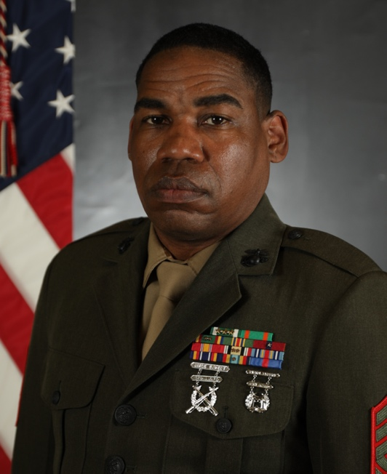
Master Sergeant Hauser enlisted in the United States Marine Corps Delayed Entry Program in December of 2001 and completed recruit training at Marine Corps Recruit Depot Parris Island, South Carolina in September of 2002. Following recruit training, Master Sergeant Hauser attended Marine Combat Training at Camp Geiger, North Carolina and then reported to his primary Military Occupational Specialties School at the Naval School of Music in Virginia Beach, Virginia for the Basic Music Course. Upon graduating he was promoted to the rank of Lance Corporal.

In May of 2003, Master Sergeant Hauser reported to the 3d Marine Aircraft Wing Band, 3d Marine Aircraft Wing, Miramar, California where he served as a clarinetist and as the unit's Transportation Non-Commissioned Officer in Charge (NCIOC). In November of 2003, he was promoted to the rank of Corporal. In February of 2004 Master Sergeant Hauser deployed in support of Operation Iraqi Freedom where he served as Corporal of the Guard for the Tactical Air Command Center. Upon returning from deployment, Master Sergeant Hauser served as the Assistant Enlisted Conductor, Public Affairs NCOIC and attended Corporals Course. In June of 2005 he was promoted to the rank of Sergeant.

Master Sergeant Hauser deployed again in August of 2006 with 3D Low Altitude Air Defense Battalion, MWSG-37 where he served as Sergeant of the Guard. Master Sergeant Hauser reported to the Parris Island Marine Band, Parris Island, South Carolina in August of 2007 where he served as a clarinetist, Public Affairs NCOIC, and Assistant Enlisted Conductor. He was promoted to the Rank of Staff Sergeant in July of 2008 and assumed the duties of Acting Enlisted Conductor. Master Sergeant Hauser was the unit's representative for Staff Non-Commissioned Officer in Charge (SNCO) Musician of the year for 2008 and 2009, and was selected to attend the Unit Leader Course at the Naval School of Music in 2009.

In December of 2010 Master Sergeant Hauser reported to the Naval School of Music to attend the Unit Leader Course. Upon graduating the course in August of 2011, he was selected to stay on staff of the Marine Detachment at the School of Music. Master Sergeant Hauser served as a Basic Academics Instructor, Rehearsal Division Instructor, and as the Equal Opportunity Representative for the Marine Detachment. He also attended the Career course and the Equal Opportunity Representative Course. He was promoted to the rank of Gunnery Sergeant in September of 2014 and attended the Senior Musician Course where he was awarded the BMOS of 5519, Enlisted Conductor.

Master Sergeant Hauser reported to the Marine Forces Reserve Band, Marine Forces Reserve, New Orleans, Louisiana in May of 2015 where he served as the Enlisted Conductor. While stationed in New Orleans, Master Sergeant Hauser planned and oversaw the band's concert tour in support of the Centennial of the Marine Forces Reserve. The tour spanned numerous cities to include New York, Boston, and San Juan, Puerto Rico. In 2017 Master started serving as the Bandmaster of the unit, he also attended the Advanced Course in 2018, and the Basic Recruiter Course in 2019. In March of 2019 Master Sergeant Hauser reported to the 4th Marine Corps District for assignment as the Musical Technician Assistant.

In April of 2019 he attended the Audition Training Course at the Naval School of Music. Master Sergeant Hauser oversees every MEAP accession for the 4th Marine Corps District as well as presenting in high schools, colleges, and universities across the District. Master Sergeant Hauser was promoted to the Rank of Master Sergeant in January of 2021.

In March of 2022, Master Sergeant Hauser assumed his current role as the Bandmaster / Staff Non-commissioned Officer In Charge of the Marine Forces Reserve Band in New Orleans, LA.

Master Sergeant Hauser's awards include the Navy and Marine Corps Commendation Medal (gold star in lieu of fourth award), the Navy and Marine Corps Achievement Medal, and several Letters of Appreciation, Meritorious Masts, and Certificates of Commendation.

ENLISTED CONDUCTOR

GUNNERY SERGEANT AMANDA KRANENDONK

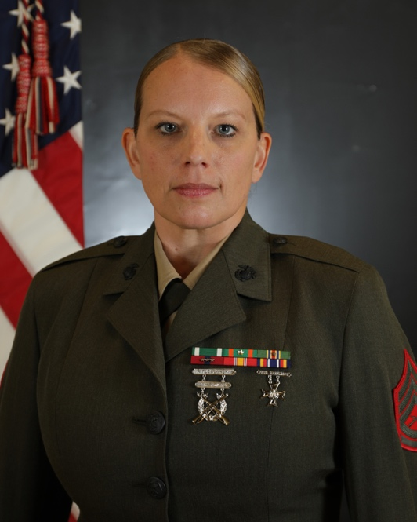
Gunnery Sergeant Amanda Kranendonk is originally from Dunwoody, Georgia. She earned a bachelor’s degree in music performance with an emphasis in oboe from Brigham Young University in 2006. There she studied with Dr. Geralyn Giovannetti. In the fall of 2006, GySgt Kranendonk began her master’s degree at Georgia State University studying with Dr. Lara Dahl.
GySgt Kranendonk enlisted in the Marine Corps in February 2008. After completing recruit and combat training in August 2008, Private First Class Kranendonk reported to the Marine Detachment, Naval School of Music in Virginia Beach. There she received further oboe instruction from Mr. Kevin Piccini. She also completed her master’s degree in music performance from Georgia State University.
Following graduation from the Naval School of Music in December 2008, Lance Corporal Kranendonk reported to Marine Corps Logistics Base in Albany, Georgia as an oboe instrumentalist for the Albany Marine Band. She also served as the Non-Commissioned Officer in Charge of woodwind quintet, double reed section leader, and the band’s Operations Chief. During this tour she was promoted to Corporal and Sergeant.
In May of 2012, Sergeant Kranendonk reported once again to the Naval School of Music in Virginia Beach to serve as the oboe instructor. She also taught small ensembles for the school’s rehearsal division. In 2015 Sergeant Kranendonk was recognized as the Naval School of Music Instructor of the Year and was promoted to Staff Sergeant that same year.
In January of 2016, Staff Sergeant Kranendonk attended the Unit Leader Course at the Naval School of Music. Following graduation in August of 2016, SSgt Kranendonk reported to the Marine Corps Forces, Pacific Band in Kaneohe Bay, Hawaii. She served as oboe instrumentalist, Staff Non-Commissioned Officer in Charge of woodwind quintet, and was selected for the billet of Enlisted Conductor in February of 2020.
​In December 2020, SSgt Kranendonk reported to Marine Forces Reserve Band in New Orleans, Louisiana as the Enlisted Conductor. She was promoted to Gunnery Sergeant in July of 2022. Her personal awards include: Navy and Marine Corps Commendation Medal, Navy and Marine Corps Achievement Medal (second award), Navy Meritorious Unit Commendation (second award), and Good Conduct Medal (fifth award).

DRUM MAJOR

STAFF SERGEANT JOSHUA T. WAGNER

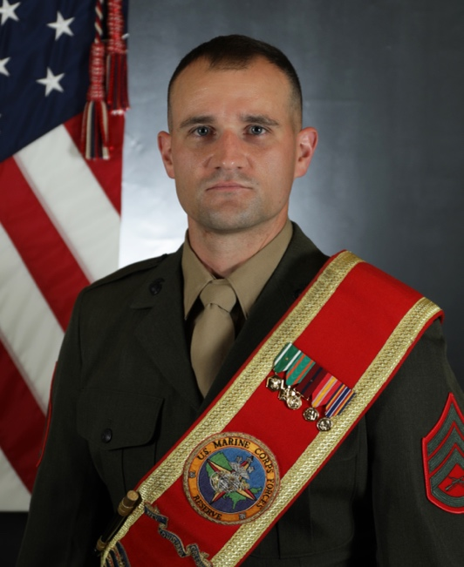
Staff Sergeant Joshua Wagner is a native of Crete, Illinois. He earned a bachelor’s degree in music performance from Illinois State University in 2011 where he studied with Dr. Joe Neisler, and a master’s degree in music performance from the University of New Mexico in 2013 where he studied with Prof. JD Shaw.

SSgt Wagner enlisted in the Marine Corps in July of 2014. After completing recruit and combat training in November 2014, Private First Class Wagner reported to the Marine Detachment, Naval School of Music in Virginia Beach where he received further horn instruction from Staff Sergeant Zachary Wills.

Following graduation from the Naval School of Music in April 2015, Lance Corporal Wagner reported to Marine Corps Base Quantico in Quantico, Virginia as a French horn instrumentalist for the Quantico Marine Corps Band. He performed in the concert band, ceremonial band, brass quintet, horn quartet, and barber shop quartet. During this tour he was promoted to Corporal and Sergeant.

In February of 2018, Sergeant Wagner reported back to the Naval School of Music in Virginia Beach to serve as the French horn instructor. He also served in the school’s academics division, teaching music theory and ear training. In 2020, Sergeant Wagner was recognized as the Junior Instructor of the Year for both the Naval School of Music and the Center for Service Support. During this tour, he was promoted to Staff Sergeant.

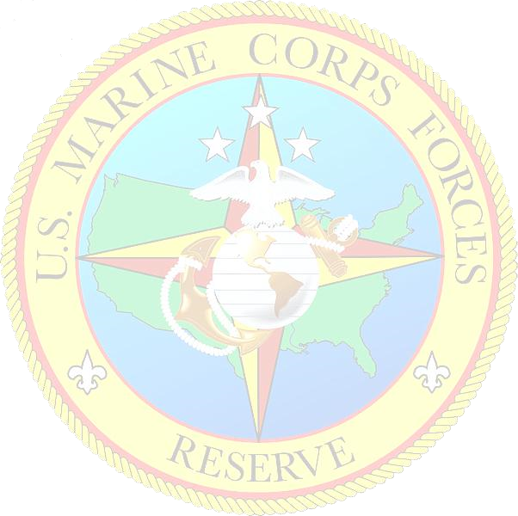
In January of 2022, Staff Sergeant Wagner attended the Unit Leader Course at the Naval School of Music where he developed skills in advanced music theory, arranging, rehearsal techniques, conducting, and drum majoring.

In August of 2022, SSgt Wagner reported to Marine Forces Reserve Band in New Orleans, Louisiana where he is currently serving as the acting Drum Major and French horn instrumentalist. His personal awards include: Navy and Marine Corps Commendation Medal (second award), Navy and Marine Corps Achievement Medal, and Good Conduct Medal (second award).

SMALL ENSEMBLE LEADER

GUNNERY SERGEANT JUSTIN A. BILLINGSLEY

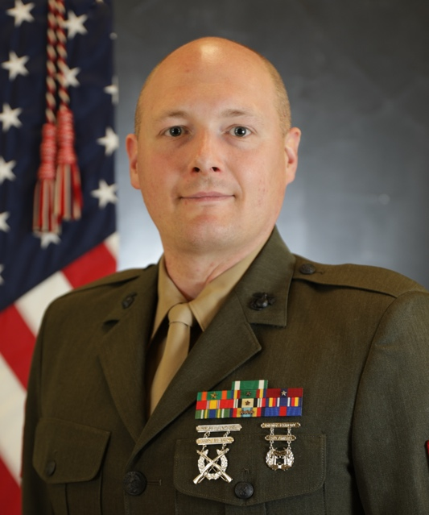
Gunnery Sergeant Justin A. Billingsley is a native of Union City, PA. He enlisted in the Marine Corps in July 2003 and attended Recruit Training at Marine Corps Recruit Depot Parris Island, SC. Upon completion of recruit training, Billingsley attended the Basic Course of Instruction at the Navy School of Music in Little Creek, VA. While there, he was promoted to Lance Corporal.
In May of 2004, Billingsley was assigned to the Third Marine Aircraft Wing Band at Marine Corp Air Station Miramar, San Diego, CA. While stationed there he served as electric bass instrumentalist, picked up the ranks of Corporal and Sergeant, and deployed to Al Asad, Iraq in support of Operation Iraqi Freedom. In October of 2007, Billingsley transitioned out of the Marine Corps to attend college.
In April of 2008, Billingsley decided to return to the Marine Corps, and was assigned to the First Marine Division Band in Camp Pendleton, CA where he served as electric bass instrumentalist, rhythm section leader, Library NCOIC, Public Affairs NCOIC, and platoon sergeant. In May of 2012, Billingsley was promoted to the rank of staff sergeant.
In July of 2012, Billingsley was assigned to the III Marine Expeditionary Force Band in Okinawa, Japan where he served as the Training SNCOIC and platoon sergeant.
In April of 2015, Billingsley received orders to the Basic Recruiters Course at Marine Corps Recruit Depot San Diego. Upon graduation from this course, Billingsley was assigned to Recruiting Station Richmond. He was placed at Recruiting Sub-Station Richmond South where he served as a Canvassing Recruiter, Assistant SNCOIC, and Pool Program Specialist.
In September of 2018, Billingsley was transferred back to the Third Marine Expeditionary Force Band in San Diego, CA where he served as Training Chief and SNCOIC of their popular music group, “Cleared Hot!”
In December of 2020, Billingsley returned to the Navy School of Music and attended the Unit Leaders Course of instruction. Upon completion of the Unit Leaders Course in 2021, Billingsley was assigned to his current unit, the Marine Forces Reserve Band, where he is currently serving as their Small Ensemble Leader.
Gunnery Sergeant Billingsley’s awards include the Navy and Marine Corps commendation Medal; Navy and Marine Corps Achievement Medal, gold star in lieu of second award; Navy Unit Commendation Medal; Good Conduct Medal, silver star in lieu of sixth award; National Defense Medal; Operation Iraqi Campaign Medal; Global War on Terrorism Service Medal; Korea Defense Medal; Sea Service Deployment Medal, three bronze stars in lieu of fourth award; and the Recruiting Service Ribbon.

INSTRUMENT REPAIR TECHNICIAN

GUNNERY SERGEANT MATTHEW L. KOSCHESKI

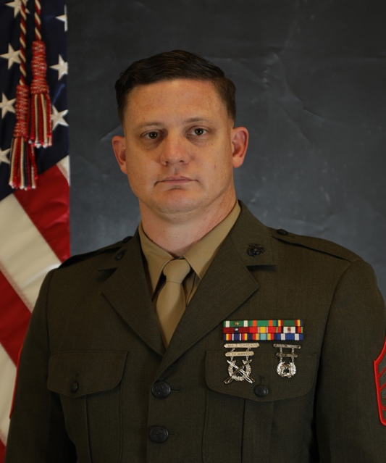
Gunnery Sergeant Matthew L. Koscheski is a native of Colorado Springs, Colorado. He enlisted in the Marine Corps in July 2003 and attended Recruit Training at Marine Corps Recruit Depot San Diego, California.
Upon completion of Recruit Training and Marine Combat Training, Private First Class Koscheski attended the Basic Course of Instruction at the Navy School of Music in Virginia Beach, Virginia. While there, he was promoted to Lance Corporal.
In May of 2004, Lance Corporal Koscheski was assigned to the Marine Forces Pacific Band in Kaneohe Bay Hawaii. While stationed there he served as a Trumpet instrumentalist and trumpet section leader and was promoted to the ranks of Corporal and Sergeant.
In October of 2007, Sergeant Koscheski was assigned to the 3D Marine Aircraft Wing Band in Miramar, California where he served as the trumpet section leader and high brass group leader. In February of 2009 he was promoted to the rank of Staff Sergeant. From October 2010 to March 2011, SSgt Koscheski was deployed to Afghanistan in support of Operation Enduring Freedom, where he served as the Squadron S-3 chief for Marine Wing Headquarters Squadron 3 (Forward) and Entry Control Point Security chief for the 3D Marine Aircraft Wing (Forward).
In August 2011, Staff Sergeant Koscheski was assigned to the Marine Corps Forces Reserve Band in New Orleans, Louisiana. During his tour with the MARFORRES Band, Staff Sergeant Koscheski served as the High Brass group leader, platoon sergeant, and Assistant Instrument Repair Technician.
In February 2014, Staff Sergeant Koscheski was selected for his current billet as Instrument Repair Technician and in August reported to Minnesota State College-Southeast Technical to attend the Band Instrument Repair program.
Staff Sergeant Koscheski graduated the Band Instrument Repair program in May 2015 and served as Instrument Repair Technician at the Parris Island Marine Band in South Carolina. He was promoted to his current rank of Gunnery Sergeant in August 2015.
Gunnery Sergeant Koscheski was reassigned to the 2D Marine Aircraft Wing Band in July 2019, where he currently served as Bandmaster and Instrument Repair Technician.
In September, 2022 Gunnery Sergeant Koscheski was assigned to the Marine Forces Reserve Band where he currently serves as the Instrument Repair Technician.
Gunnery Sergeant Koscheski’s awards include the Navy and Marine Corps Commendation Medal (2nd Award), Navy and Marine Corps Achievement Medal, Navy Unit Citation, Good Conduct Medal (6th award), National Defense Service Medal, Afghanistan Campaign Medal (2nd Award), Global War on Terrorism Service Medal, Sea Service Deployment Ribbon, and Non-Article 5 NATO medal.

ENSEMBLES

CONCERT BAND
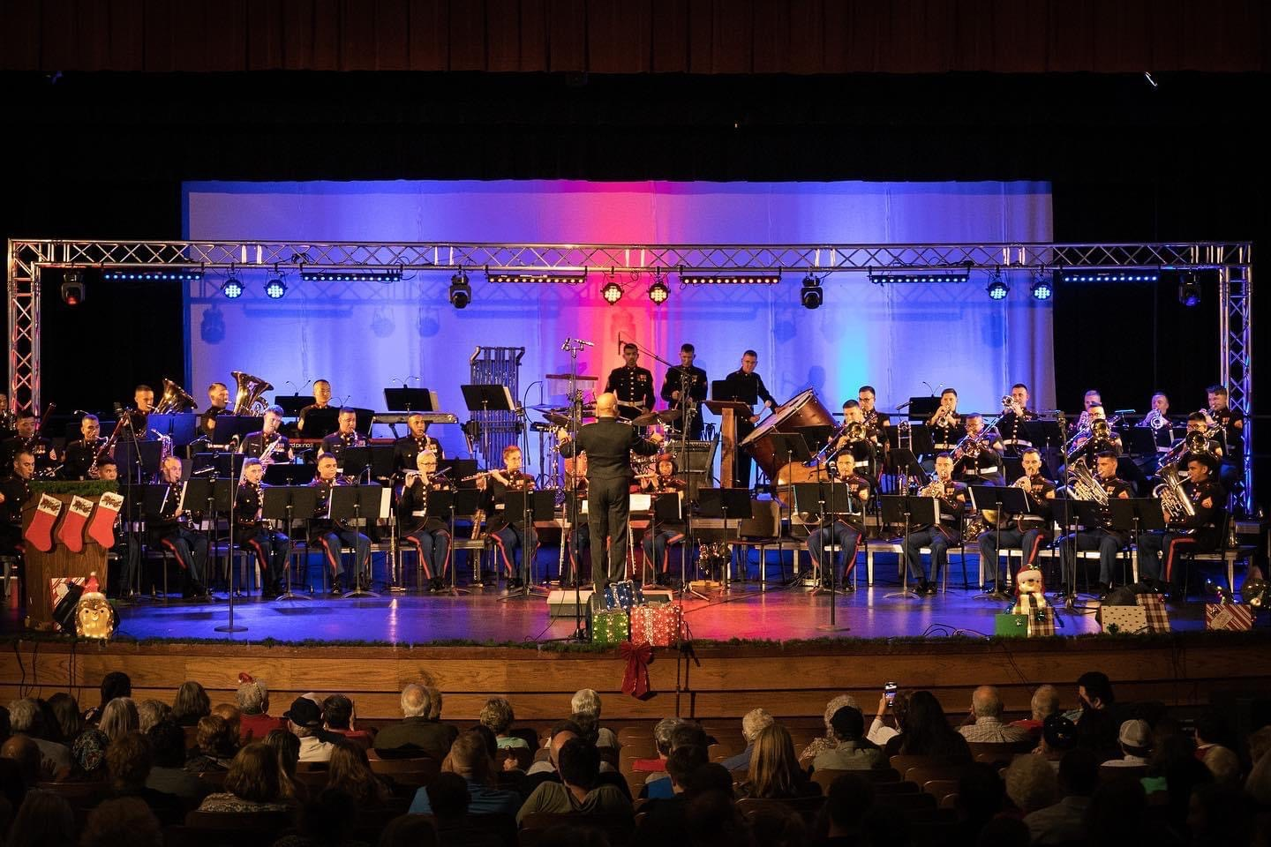
The concert band utilizes nearly every musician in the unit, making it the largest ensemble of the band. From Gustav Holst to John Williams, the concert band performs a variety of contemporary and traditional wind band literature, orchestral transcriptions, pop arrangements, and concert marches. The ensemble travels frequently across the country, performing many concerts for communities and educational institutions. Noteworthy performances include: The Fiesta Days Celebration concert at the historical Alamo in San Antonio, TX; The Battle of the Atlantic Ceremony in Calgary, Canada; touring from Puerto Rico to Boston, MA for the United States Marine Corps Reserve Centennial Celebration; and the annual Toys for Tots Christmas Production tour.

ENSEMBLES

CEREMONIAL BAND
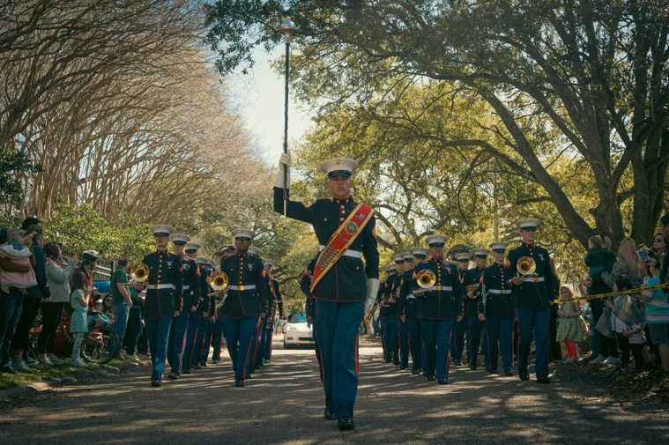
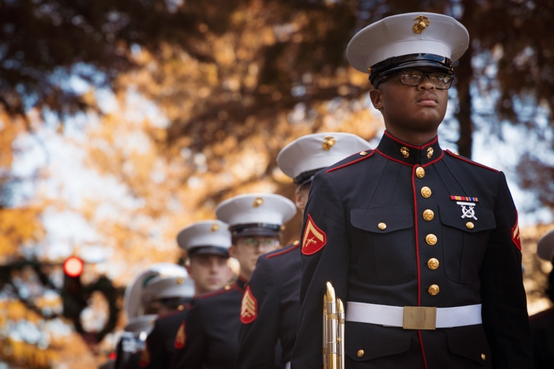
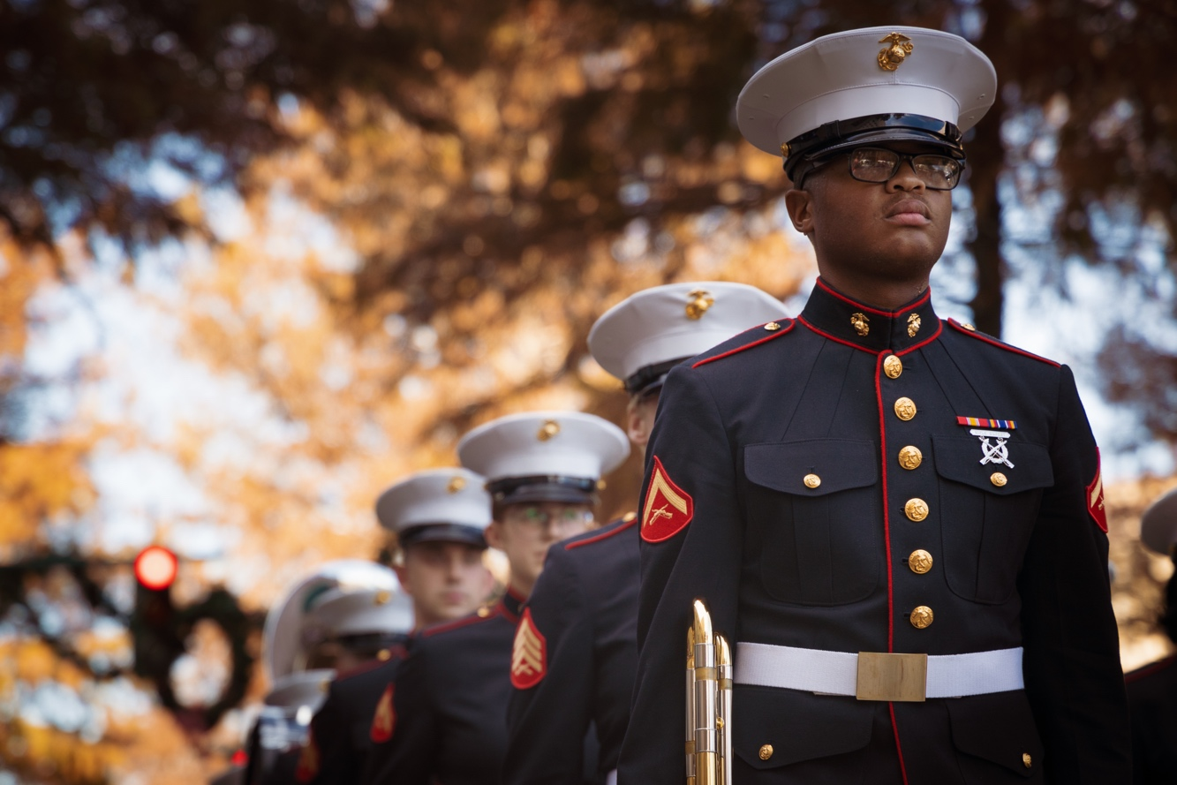
The ceremonial band is the most traditional and versatile of the band’s ensembles, and as such it is the most frequently requested musical unit. Whether marching in hometown parades, military ceremonies, or patriotic openings for professional sporting events, the ceremonial band utilizes its assorted repertoire to entertain hundreds of thousands of spectators yearly. This ensemble performs a wide range of selections, from marches and jazz standards, to pop tunes and rock and roll classics. Notable ceremonial band performances include The United States Marine Corps Reserve Centennial Celebrations in New York City, Boston, and Puerto Rico; participation in annual Mardi Gras events in and around the New Orleans area; international joint military performances; pre-game patriotic and half-time events in Gillette Stadium for the New England Patriots; and multiple New Orleans Saints pre-game and half-time performances.

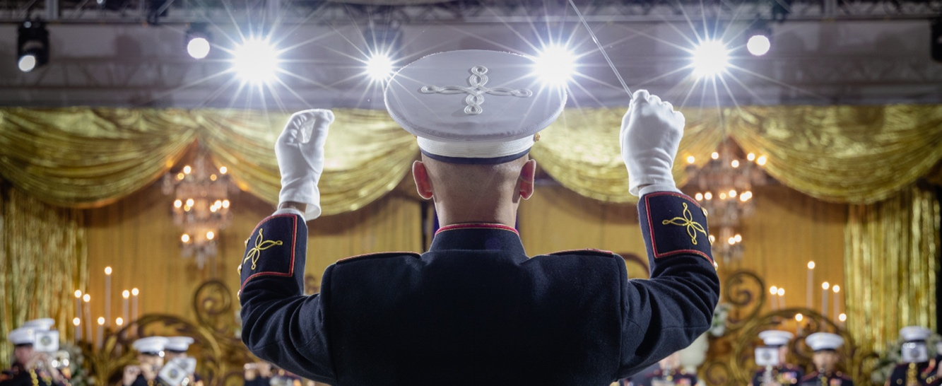

ENSEMBLES

JAZZ COMBO

The jazz combo features a group of dynamic musicians, performing everything from traditional jazz standards and bebop to fusion and Latin. Performing at numerous official and community events, this group brings to life the music of some of America’s greatest songwriters and composers, presenting works from artists like Charlie Parker, Sonny Rollins, Freddie Hubbard, Chick Corea, and Antonio Carlos Jobim. The ensemble’s most notable performances include the William J. Clinton Presidential Library dedication in Little Rock, AR; performing at Sousa Hall, Marine Barracks 8th & I in
Washington, DC; and featured performances at the National Jazz Historical Park in New Orleans.
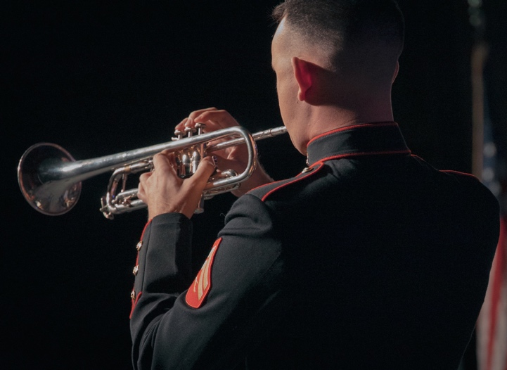
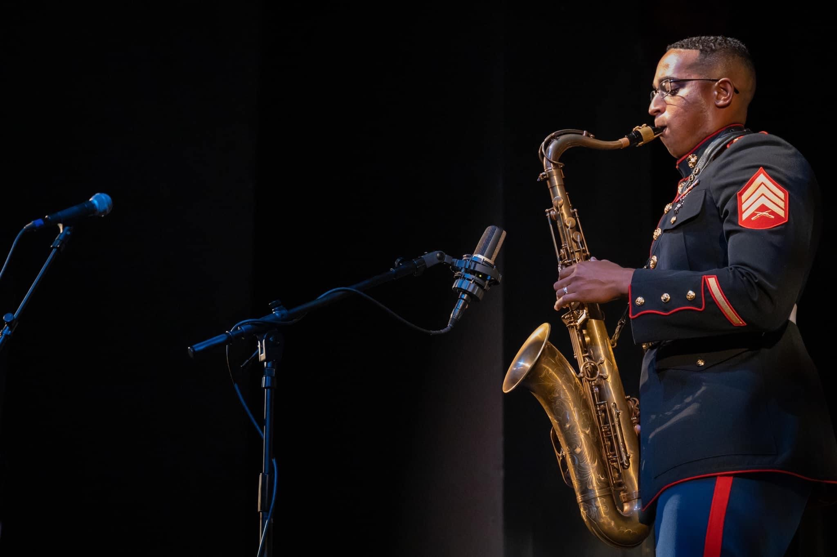

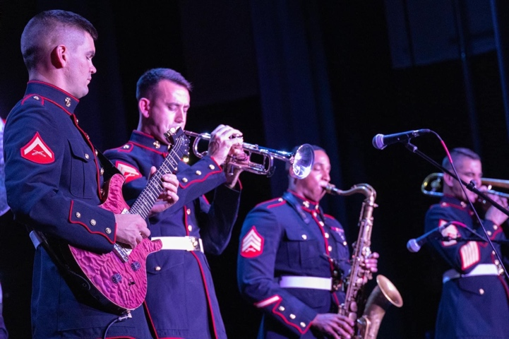

ENSEMBLES

ROCK BAND
One of our most flexible and crowd-pleasing ensembles is the rock band, performing for thousands of people annually at civic, community, and educational events. Comprised of electric guitar, bass guitar, keyboard, drum set, various wind instruments, and vocals, the ensemble’s repertoire includes a wide variety of genres such as classic rock, pop music, country western, and radio “Top 40” hits. Just like the rest of our small ensembles, all members of the rock band component are full-time members of the Marine Forces Reserve Band. Performances of note include the Houston Rodeo Tent Nights in Houston, TX; The Sugar Bowl Tailgate Event in New Orleans, LA; The Veteran’s Salute at the Mercedes Benz Superdome’s Champion Square in New Orleans, LA; and the New Orleans Saints Pregame Event.

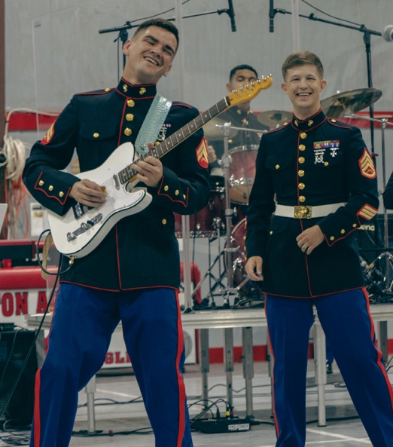

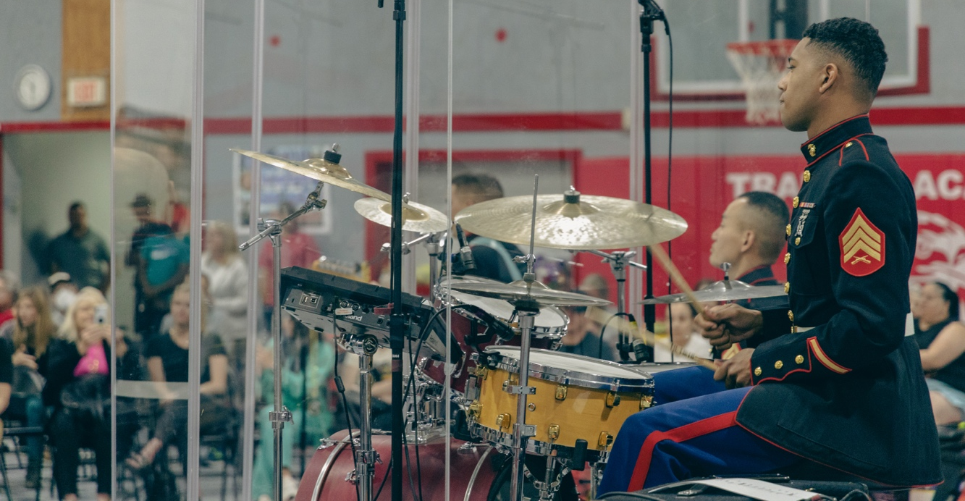

ENSEMBLES
BRASS BAND
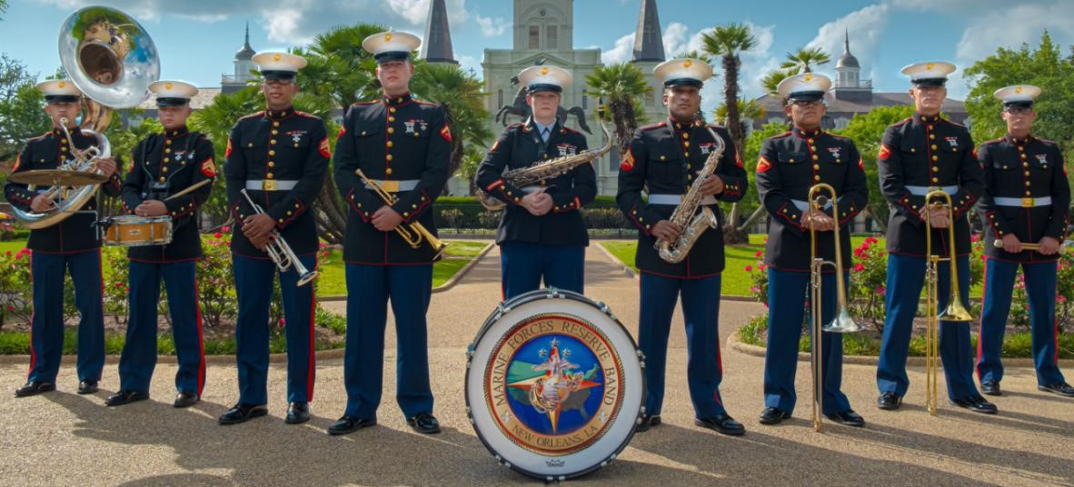
The brass band is one of our most recognizable and energetic groups within the band. Well known for displaying individual talents through instrumental solos and improvisation. Their style is drawn straight from the musical influences of New Orleans’ Dixieland jazz. The ensemble consists of trumpets, saxophones, trombones, sousaphone, and various percussion. The brass band requires no electric amplification and thus is a highly mobile ensemble, perfect for playing in festivals, parades, outdoor concerts and many televised performances, such as the Rex Mardi Gras Ball and Fox 3 “Celebration in the Oaks” event. In addition to frequent performances around New Orleans’ historic and famed French Quarter, the brass band has also performed in Washington, DC at 8th & I. In the summer of 2010, they also participated in Operation Shared Accord in Mozambique, Africa.

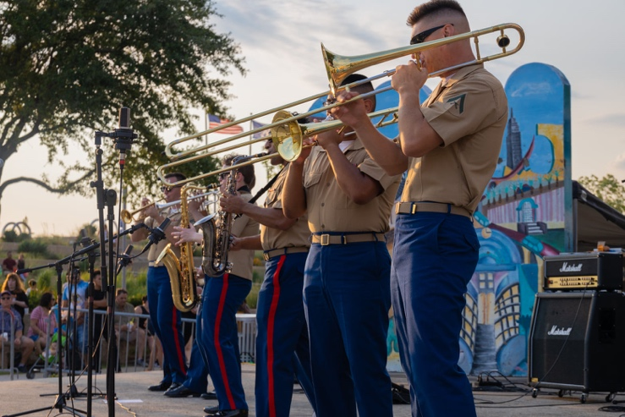
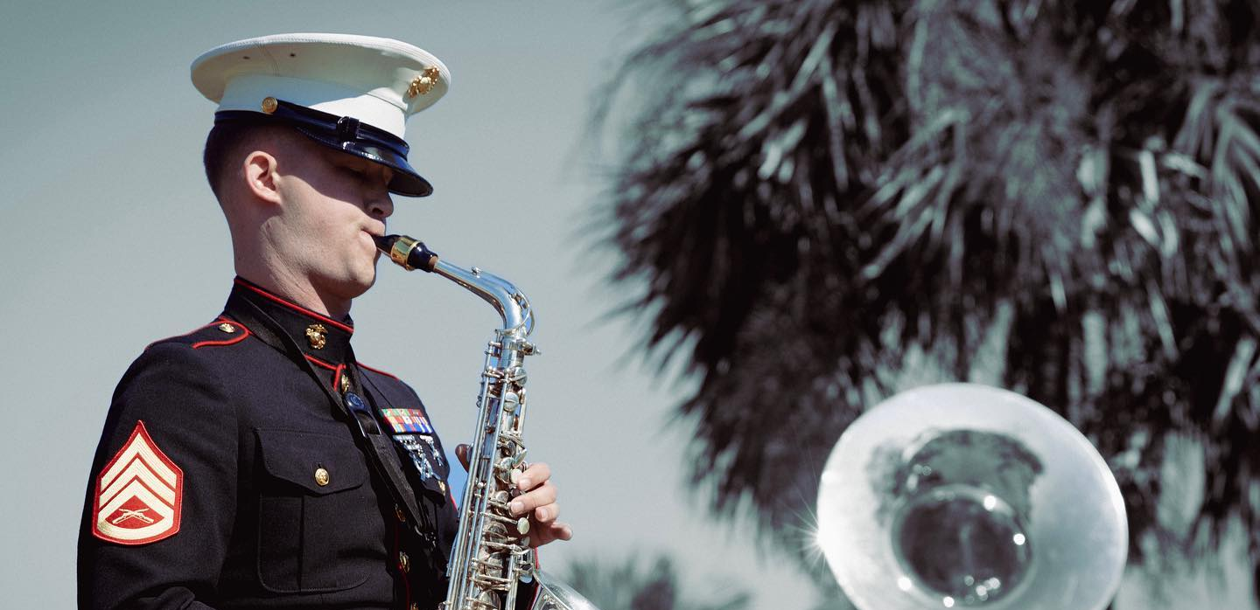

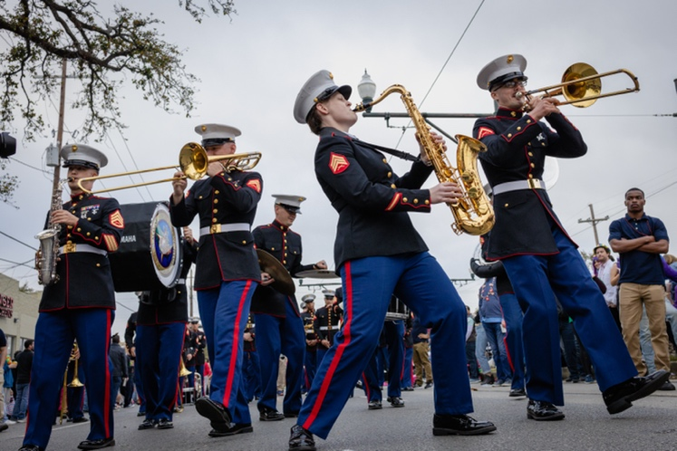
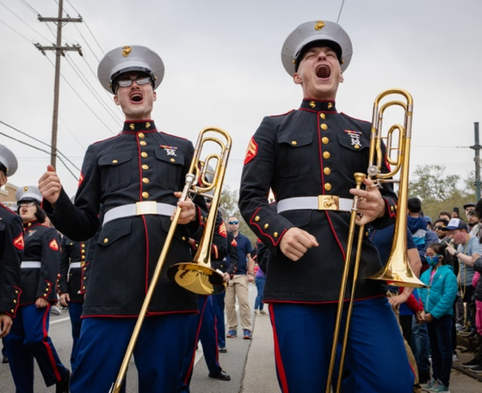

ENSEMBLES

WOODWIND QUINTET
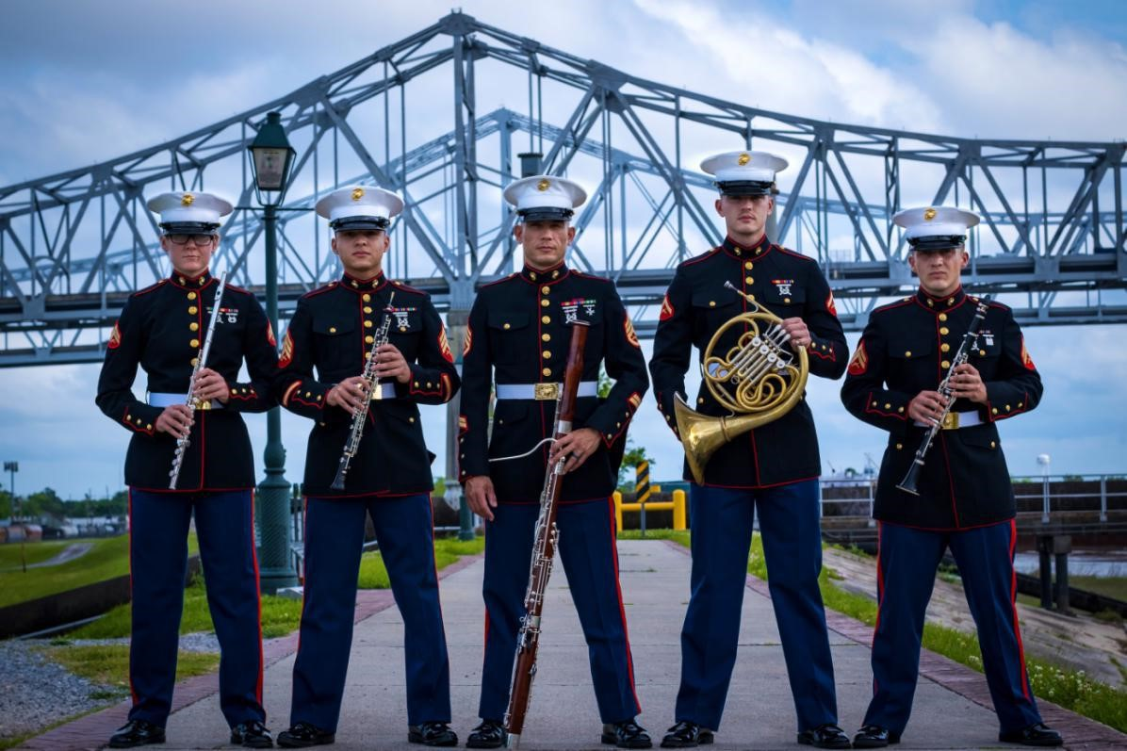
The quintet regularly performs in various civic events and ceremonies for Marine Forces Reserve and other military organizations. The Marine Forces Reserve Band Woodwind Quintet is comprised of a flute, oboe, clarinet, horn and bassoon. Along with the brass quintet, they occasionally provide pre-concert performances for our concert band events. The group’s repertoire includes patriotic music, jazz tunes, pop transcriptions, and classical chamber selections. Performances of note include the Vietnam Moving Wall Memorial Ceremony in Kenner, LA and performances coinciding with the band’s recruiting tours spanning from Missoula, MT to Phoenix, AZ.

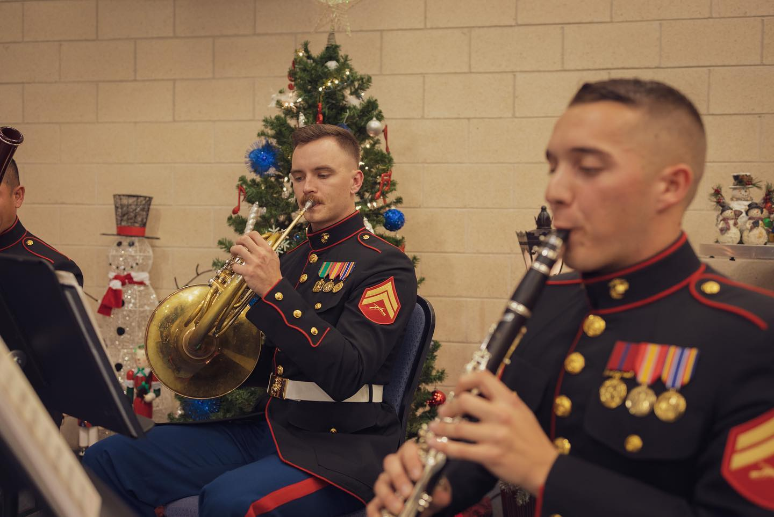
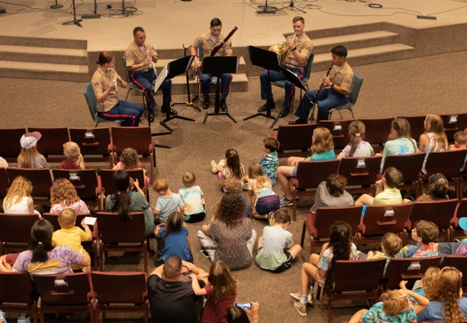

ENSEMBLES
BRASS QUINTET
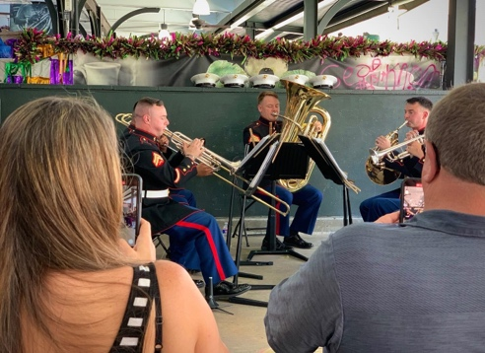
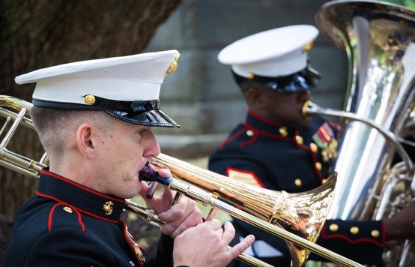
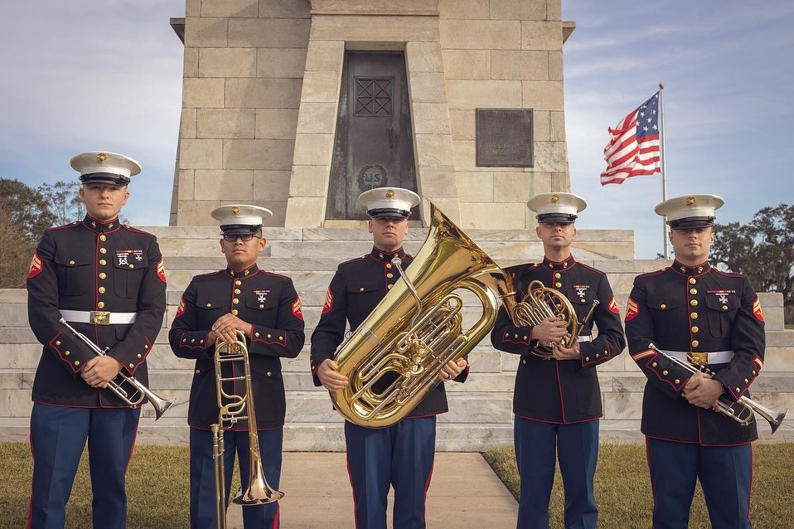
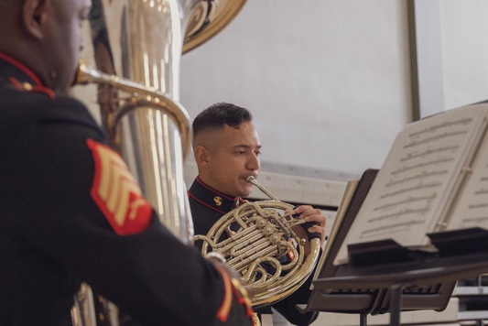
The quintet frequently tours the United States, playing at various military ceremonies, civic events, and educational venues in support of our mission of community relations. The Marine Forces Reserve Band Brass Quintet consists of two trumpets, a horn, trombone, and tuba. With unmatched diversity, this ensemble performs patriotic, classical, contemporary, and jazz literature alike. Noteworthy performances include the opening bell of the New York Stock Exchange; NBC’s “Today” Show; appearances on CNN and the Fox News Channel, and the 9/11 Memorial in New York City.

ENSEMBLES

BIG BAND
The Marine Forces Reserve Big Band is a classic example of all-American bands like the Glenn Miller and Count Basie Orchestras, the ensemble consists of saxophones, trumpets, trombones, and rhythm section and performs a wide variety of music from jazz standards to modern fusion.

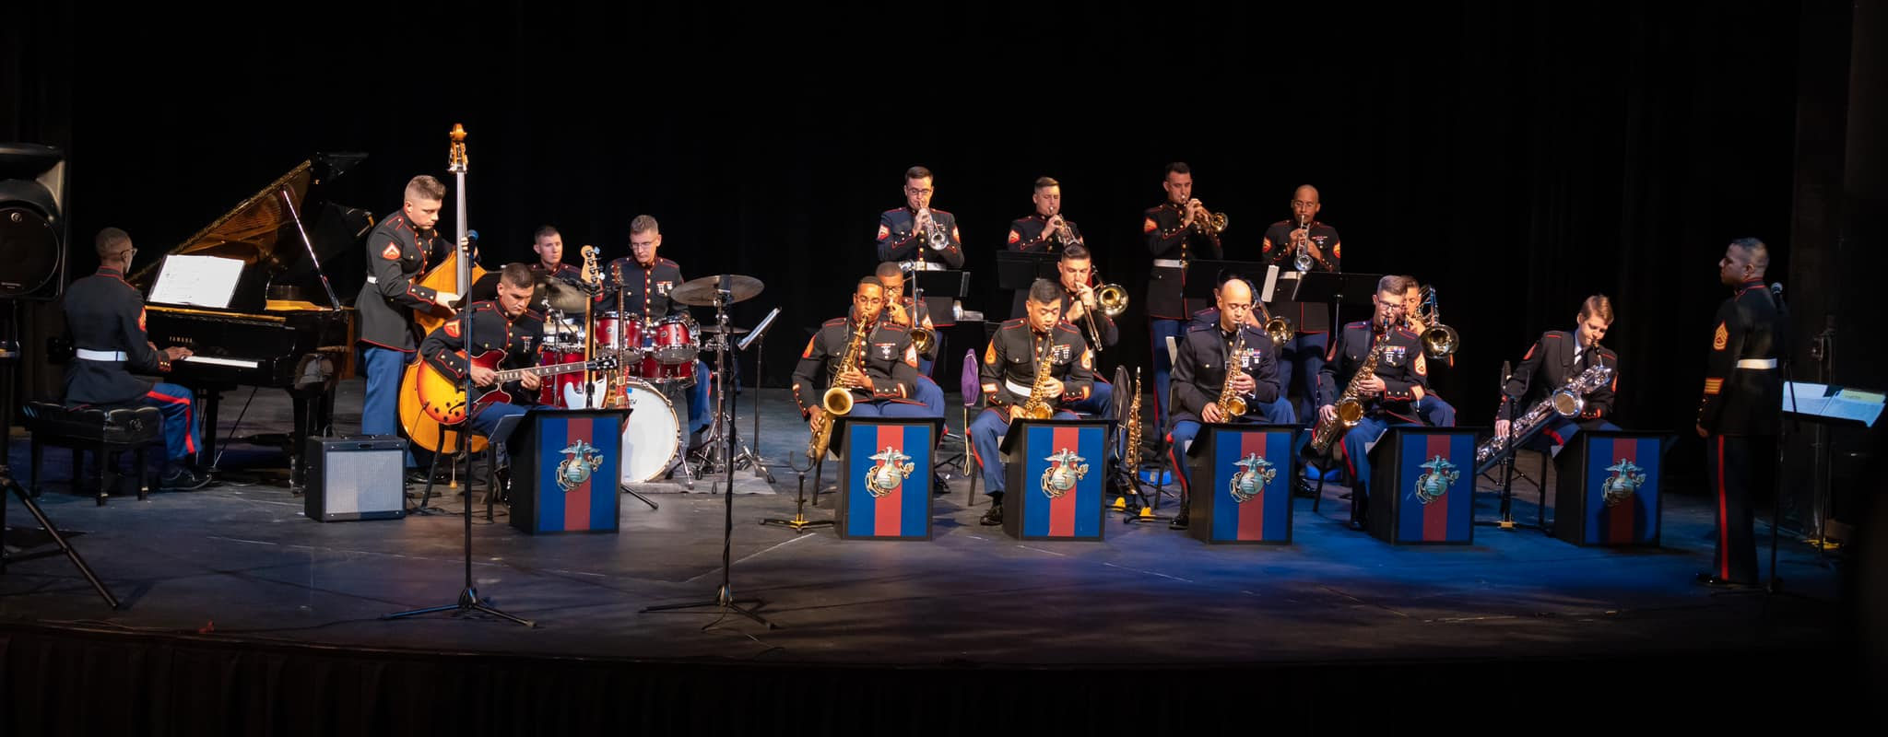

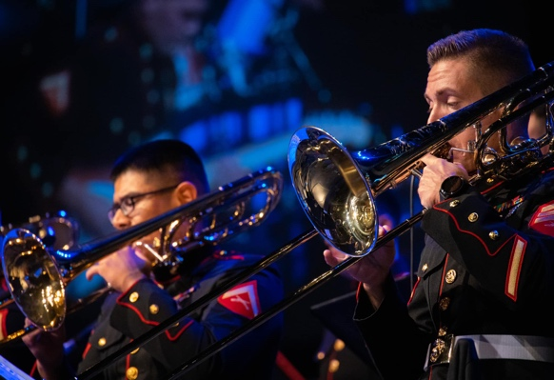
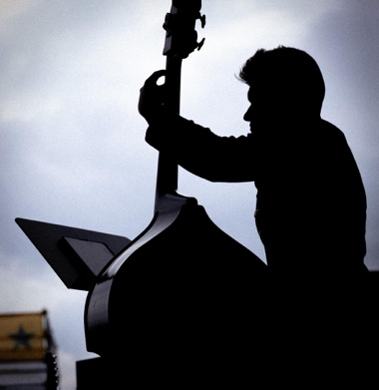
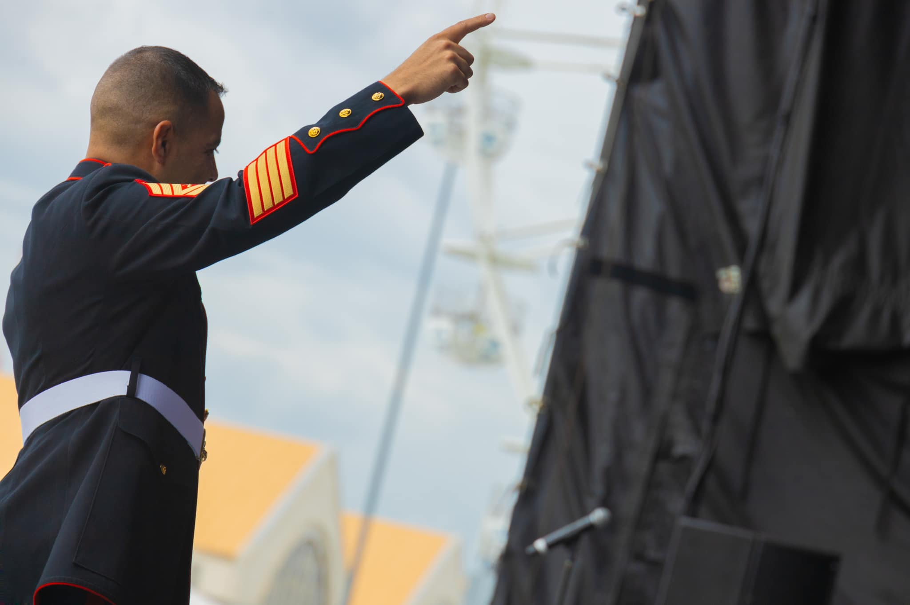

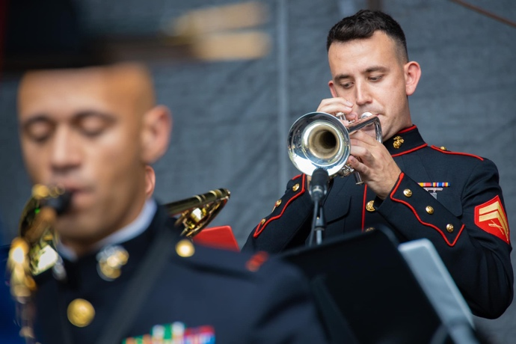
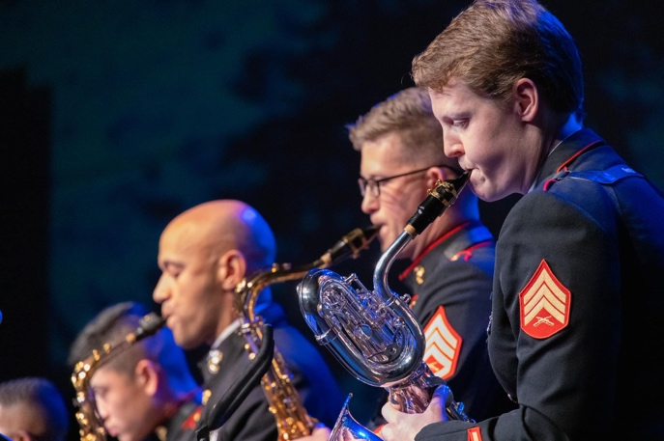

Band Roster
Director / Officer In Charge
^CWO2 Steve Talbot
Long Island, NY

Bandmaster
^MSgt Justin Hauser
Albany, NY

Enlisted Conductor
^Sgt Hannah Ford
Colorado Springs, CO
Drum Major
SSgt Joshua Wagner
Crete, IL

Flutes
*Sgt Morgan Poland
Chesapeake, VA

Cpl Hiram Carrasquillo-Rivera
San Juan, PR

LCpl Dana Waskosky
Kenosha, WI

Oboe
* LCpl Matthew Lutz
Batesville, AR

Clarinets
MSgt Justin Hauser
Albany, NY

Sgt Hannah Ford
Colorado Springs, CO

* Sgt Bridget Wenaas
Richfield, MN

Cpl Jason McIntyre
Vienna, IL

Cpl Isaac Villaro
Maui, HI

Bassoon
* SSgt James McKenzie
Daytona Beach, FL

Saxophone
GySgt Dustin Kaiser
Binghamton, NY

*SSgt Lucy Warmbrodt
Dunkirk, NY

Saxophone Cont.
Sgt Emily Poff
Huntington, IN
.
LCpl Abel Gonzalez-Ramirez
Eagle Pass, TX

Horn
* SSgt Joshua Wagner
Crete, IL

Cpl Erick Izquierdo
Hurst, TX

Cpl Liam Hanna
Norwalk, CT

Trumpet
Sgt Devin Davis
Denton, TX

Sgt Raymond Fuller
Falmouth, MA

*Sgt Brandon Hatmaker
Cleveland, TN

Cpl Connor Hazelrigg
Fresno, CA

Cpl Matthew Norkus
Point Pleasant, NJ

Trombone
*Sgt Jonathon Faz
Austin, TX

Cpl Tyren Davis
Denton, TX

Cpl Jacob Everett
Rochester, NY

Cpl Grant Gallatin
Detroit Lakes, MN

Cpl David Groome
Red Lion, PA

LCpl Kristopher Darrah
Orlando, FL

Euphonium
*Cpl Michael Cassidy
Ardmore, OK

Tuba
*SSgt Daniel Paxton
Houston, TX

LCpl Bryan Patterson
Richardson, TX

Percussion
Sgt Anfernee Williams
Cordele, GA

*Cpl Christian Barbier
Mermentau, LA

Cpl Wolfgang Lynn
LaBelle, FL

LCpl Austin Kinney
McAllen, TX

LCpl Taylor Brownfield
Ruston, LA

LCpl Torren Hamilton
Keizer, OR

Vocalist
#Sgt Dana Reminsky
Boonton, NJ

Bass
*Cpl Tristan McNay
Sacramento, CA

Piano
Sgt Jiajun Hong
Guiyang, China

Guitar
#Cpl Wolfgang Lynn
LaBelle, FL

^ Denotes Conductor
* Denotes Principal/Section Leader

# Denotes Narrator

CONNECT WITH US

WWW.FACEBOOK.COM/MFRBAND

INSTAGRAM @MFRBAND

WWW.MUSIC.MARINES.MIL/MFR

Marine Forces Reserve Band

Marine Corps Support Facility

2000 Opelousas Ave

New Orleans, LA, 70114

(504) 697-7846

Request the Marine Forces Reserve Band!
MFR.Band@USMC.MIL

