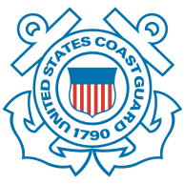
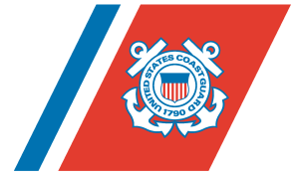
U.S. Department of
Homeland Security

United States
Coast Guard

S.S. EL FARO Marine Board of Investigation Daily Brief - Hearing Session 2, Day 6

Summarized Daily Testimony
Today’s first witnesses were Mr. Spencer Schilling, president, Herbert Engineering and Mr. Michael Newton, vice president, Herbert-ABS-Software Solutions and CargoMax. Schilling and Newton testified to general naval architecture matters under Herbert Engineering from 2003 to the present. They also testified to the Cargo Securing Manual, lashing and related technical issues.

The third witness was Mr. Randall Kidd, stevedore, PORTUS. Kidd testified to being a roll-on roll-off (RORO) stevedore head lasher who loaded the El Faro for the accident voyage. Kidd also testified to lashing issues and working with El Faro crew.

Plan for Next Hearing Day
- Captain Kevin Stith, El Yunque master

- Mr. Stephen Hohenshelt, surveyor, American Bureau of Shipping

The hearing will resume at 9 a.m. Tuesday, 24 May.

Contacts: Alana Miller, Public Affairs Office, alana.l.miller@uscg.mil, 202-372-4632
Saving Lives and Guarding the Coast Since 1790.
The United States Coast Guard -- Proud History. Powerful Future.

